Ride me

Software engineering-2 documentation

Project description: -

Ride me is an web application that helps our user to request rides and these rides gets so that they can go from one place to another. Also can offer some discount depends on the case.

Functional requirements: -

* Order ride
* Accept ride
* Find drivers
* Rate drivers
* Select offers
* Select rides
* Start a trip
* End a trip

Non-functional requirements: -

* **Availability**: The system needs to be highly available with minimal downtime.
* **Consistency**: There should be a consistent view of driver and rider data across the system to prevent conflicts and confusion.
* **Performance**: the system should be able to respond to request in small time

Sequence Diagram:-

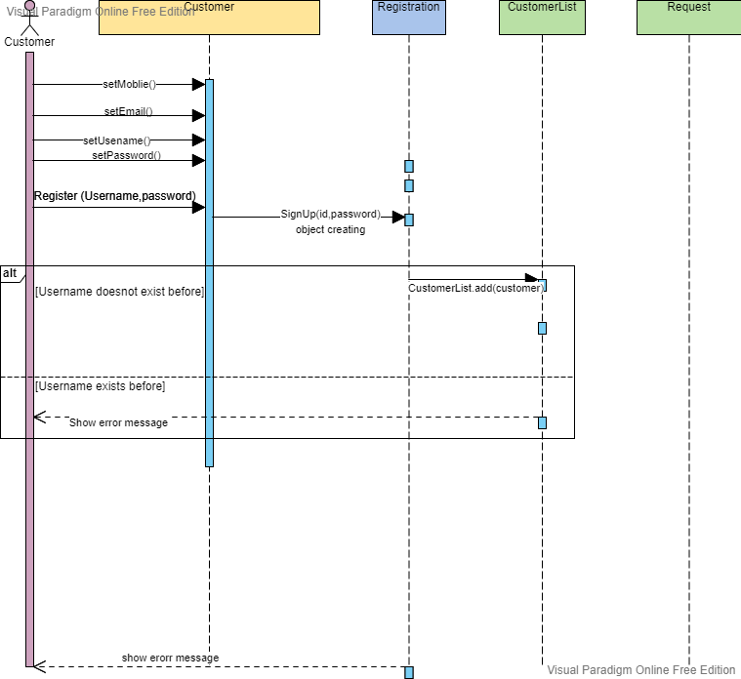

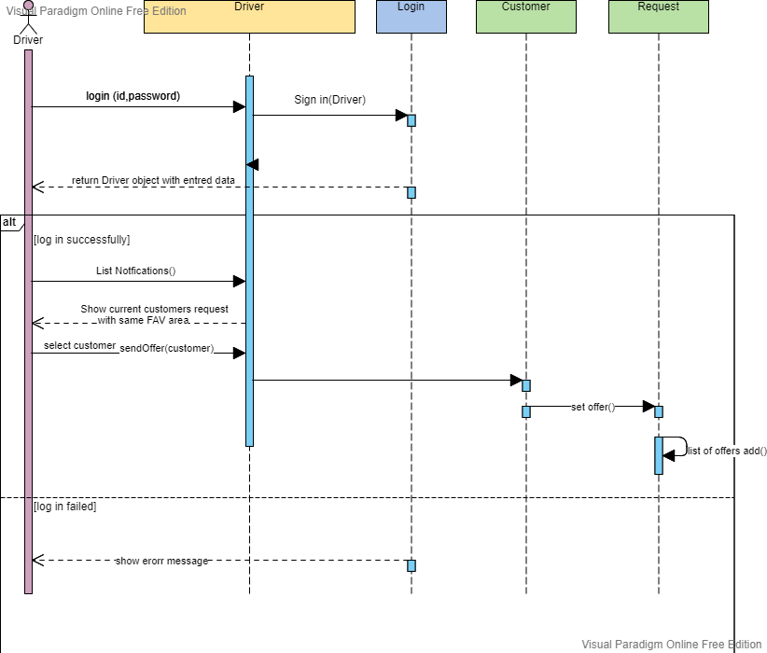

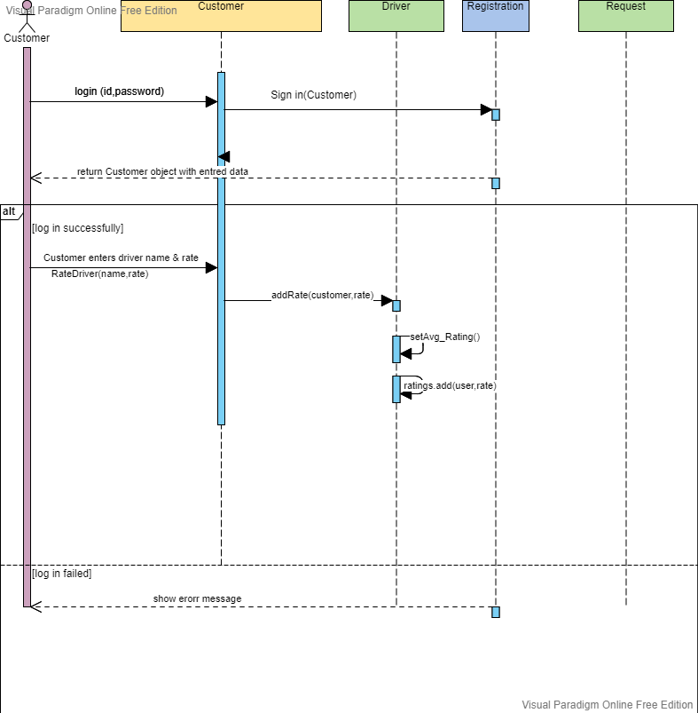

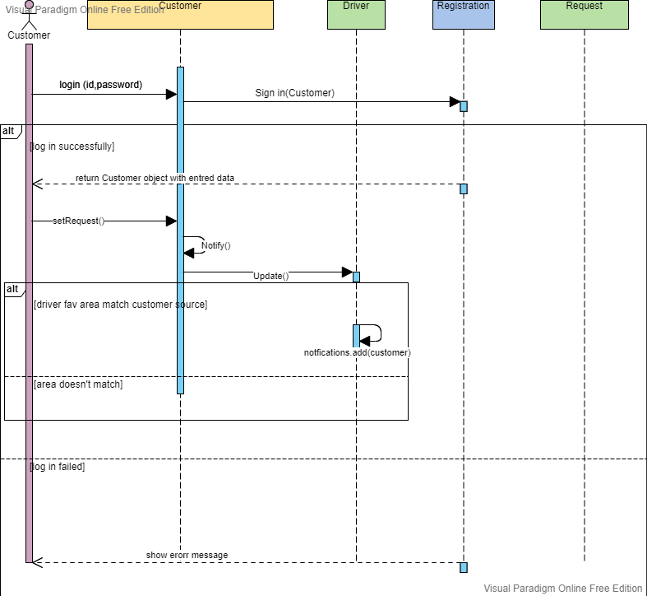

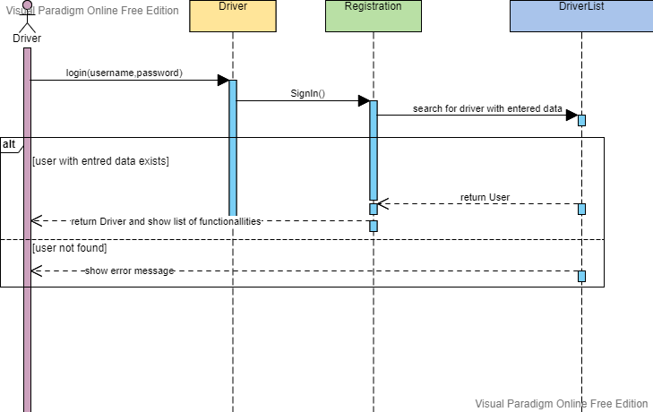

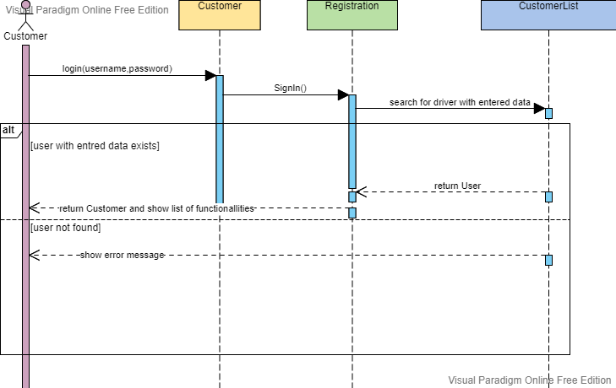

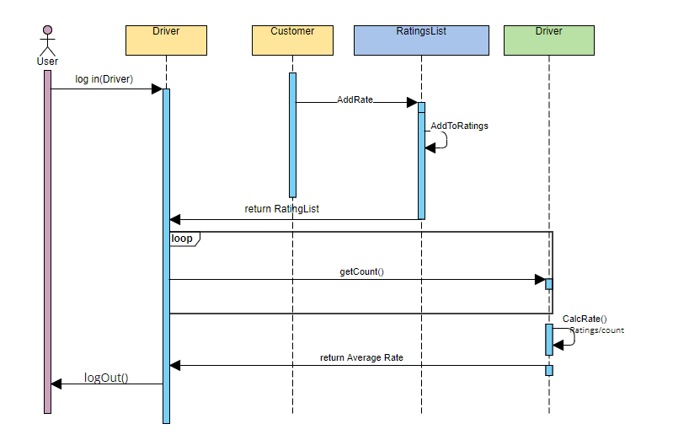

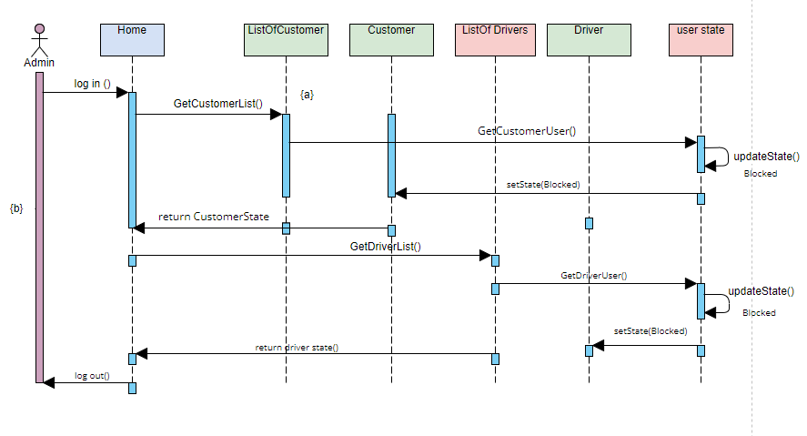

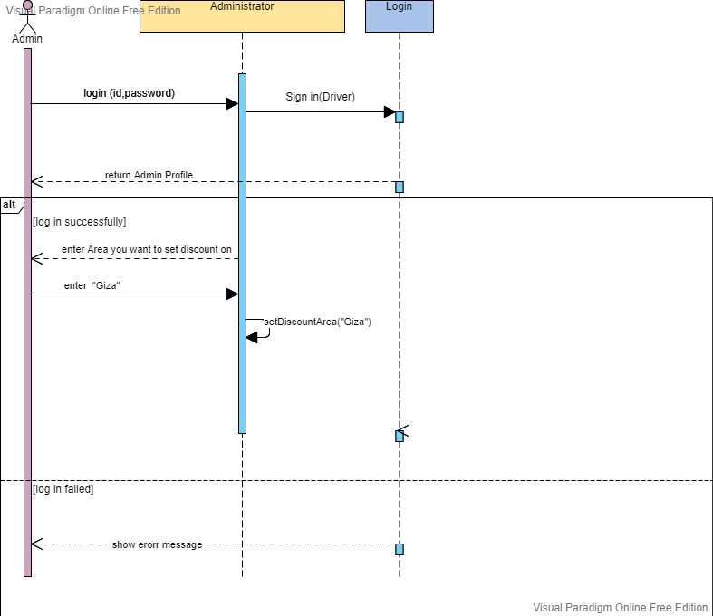

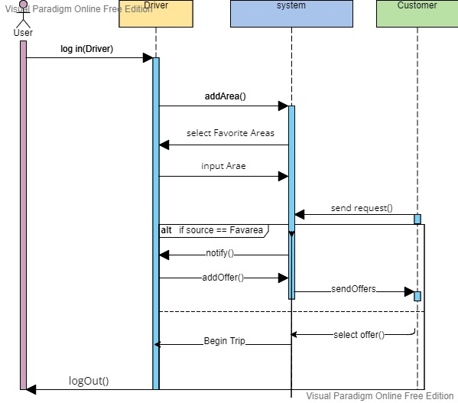

Class components diagram: -

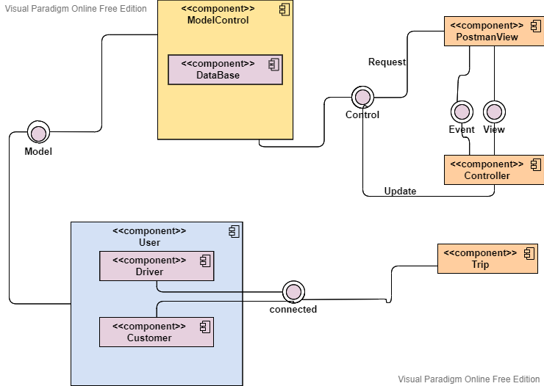

Class diagram : -

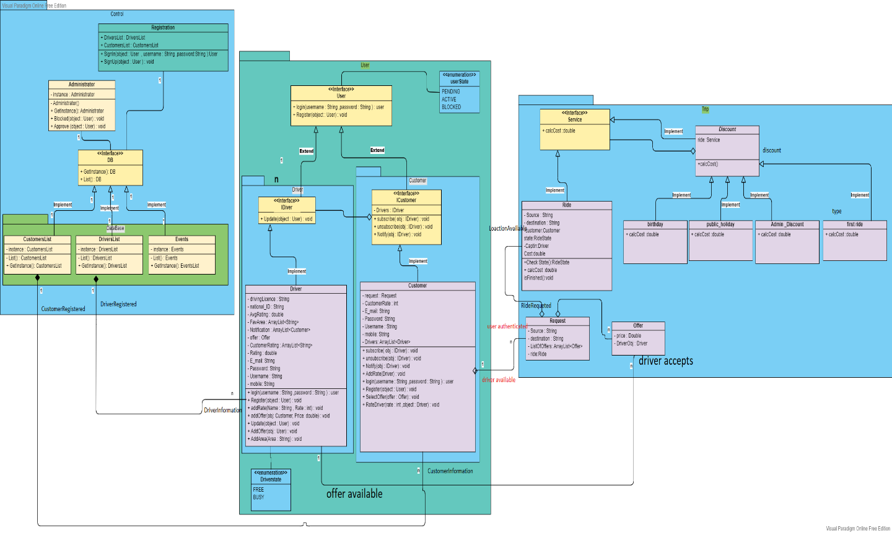

Use case diagram :-

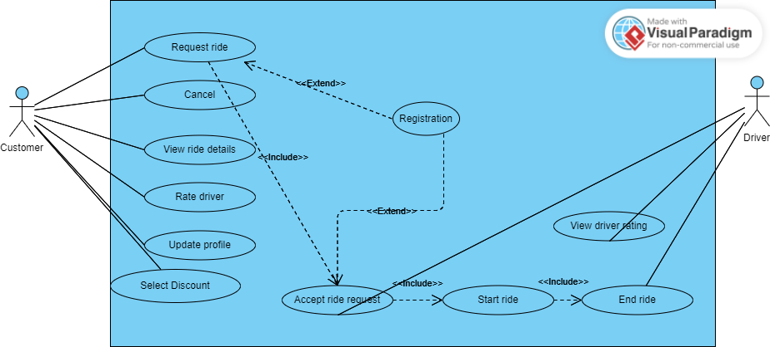

Erd diagram : -

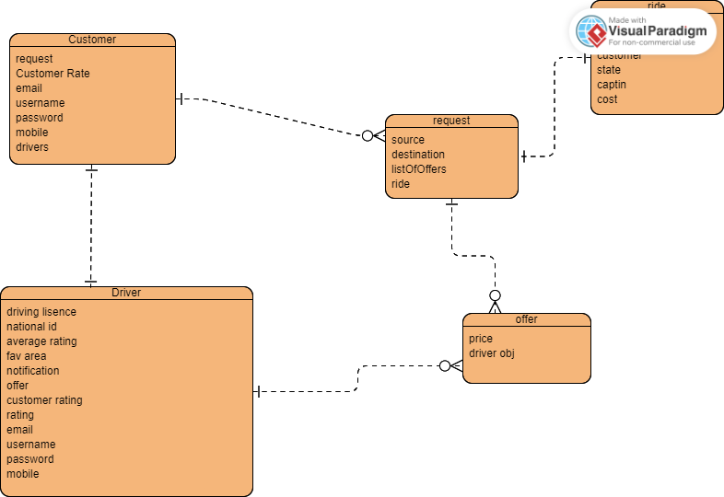

User activity diagram: -

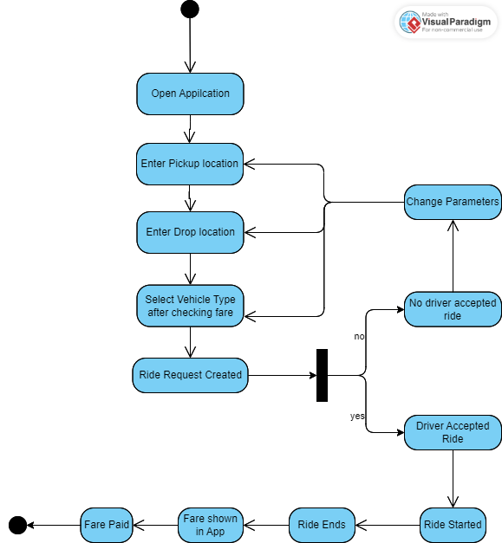

Driver activity diagram: -

